**Business Use Case Model**

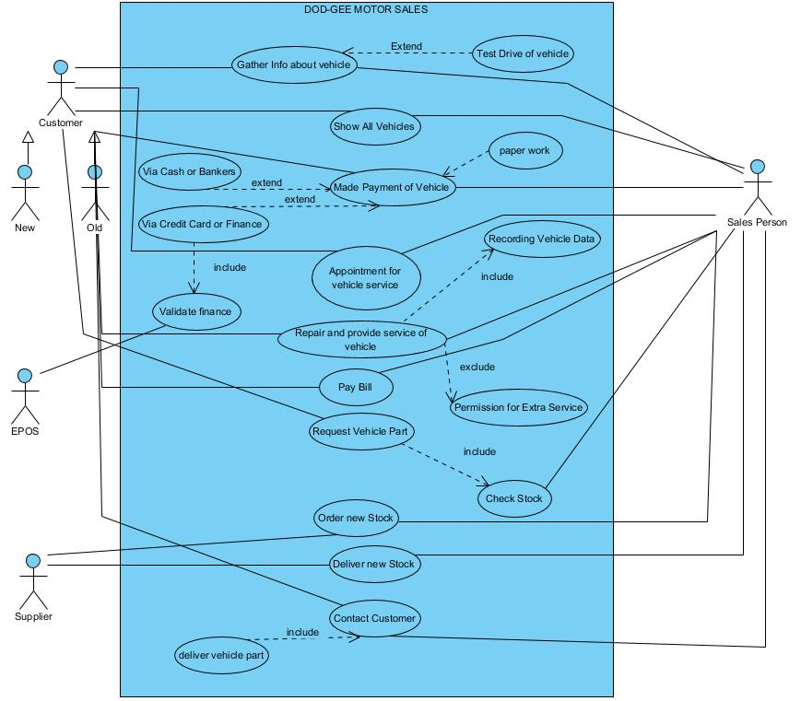

**Business Use Case Description**

|  |  |
| --- | --- |
| **Name** | **Repair and provide service for vehicle** |
| **Id** | **UC_1** |
| **Description** | **The Service providing team will provide service to the customer of their vehicle.** |
| **Pre-Condition** | **Customer wants to repair his vehicle** |
| **Post-Condition** | **Customer vehicle will be repaired or given service.** |
| **Main Course** | * When a customer wants to repair or service from our service centre, then customer has to book the appointment. * On the appointment day service team will take the vehicle and record its data in the office and start to repair the vehicle. * After successfully repairing the vehicle, the bill is handed to customer for payment * After the payment the vehicle will be handed to the customer. |
| **Alternative** | * When a vehicle need some extra service then it will be requested from the customer either we have to provide some extra service which is need the most or not. |

|  |  |
| --- | --- |
| **Name** | **Request Vehicle Part** |
| **Id** | **UC_2** |
| **Description** | **The customer request parts for their vehicle.** |
| **Pre-Condition** | **Customer needs vehicle parts for his/her vehicle** |
| **Post-Condition** | **Vehicle parts are delivered to the customer which he has ordered** |
| **Main Course** | * Whenever our customer needs the parts of their vehicle then he has to order the part from our service centre or through call. * Sometimes customer during the service of their vehicle has to order some missing parts which are not available at the service centre so then he has to order the parts. * When order is placed with payment then our service team will receive the order within 12 hour and repair the vehicle as fast as possible. * On the other hand if part is available then it is deliver to the customer with bill. |
| **Alternative** | * For public case, When the ordered part not in the stock then service team has to take and confirm order it from the ordered person and then contact manufacturer to deliver that order vehicle part to them. |

**Business Process Flow diagram**

1. **Repair or provide service for vehicle**

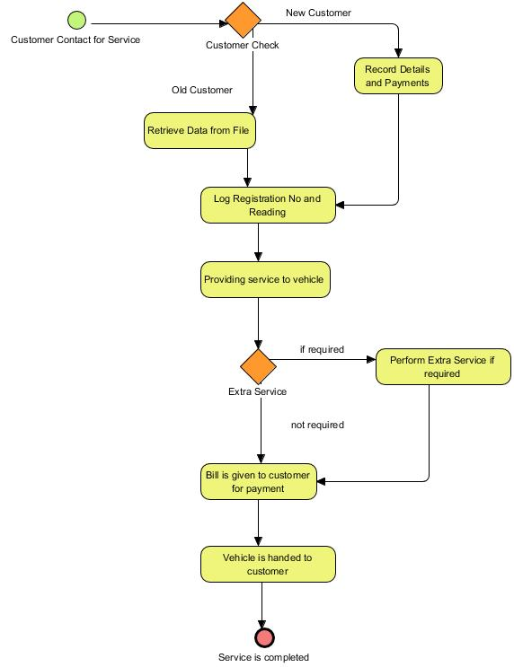

1. **Request Vehicle Part**

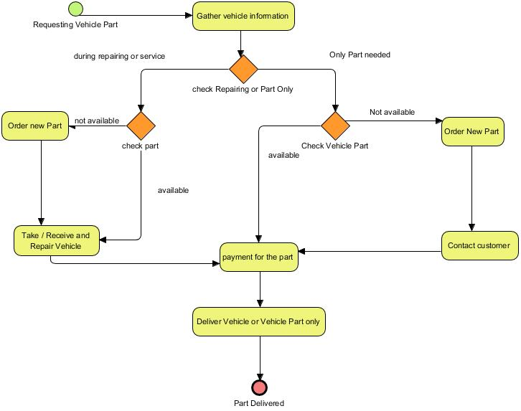

**System Requirement Model**

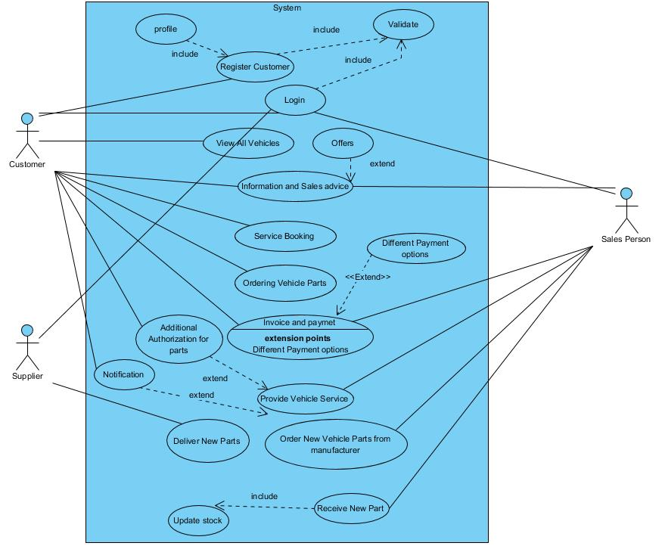

**System Use Case Description**

|  |  |
| --- | --- |
| **Name** | **Registration of Customer** |
| **Id** | **UC_3** |
| **Description** | **This is the service that will provide by the system to customers to register themselves on our website.** |
| **Pre-Condition** | **Customer don’t have an account on our website.** |
| **Post-Condition** | **Customer account will be created on our website and its profile will be managed separately.** |
| **Main Course** | * Customer go to our website URL * Then go to the register page and put all his/her personal details for registration to our website. * Then personal account for the customer will be created successfully. * Then Customer can safely book or place order. |
| **Alternative** | * When the customer don’t know how to register then they can create their account by visiting our office. |

|  |  |
| --- | --- |
| **Name** | **Ordering Vehicle Part** |
| **Id** | **UC_4** |
| **Description** | **The customer will order new parts for their vehicle using our website.** |
| **Pre-Condition** | **Customer must have an account and log in to the system.** |
| **Post-Condition** | **Customer order will placed and ordered vehicle part delivered to them.** |
| **Main Course** | * Whenever our customer needs the parts of their vehicle then he/she has to visit our website. * Then customer select the parts which are required and they will be added to customer shopping cart. * After adding the parts to cart that are needed the most them go to cart and checkout. * During checkout any payment option can be selected by our customer and order will be placed. * After specific time order will be deliver to them. |
| **Alternative** | * Customer can book the item and visit the nearest shop for picking the part by themselves. |

**Domain Model**

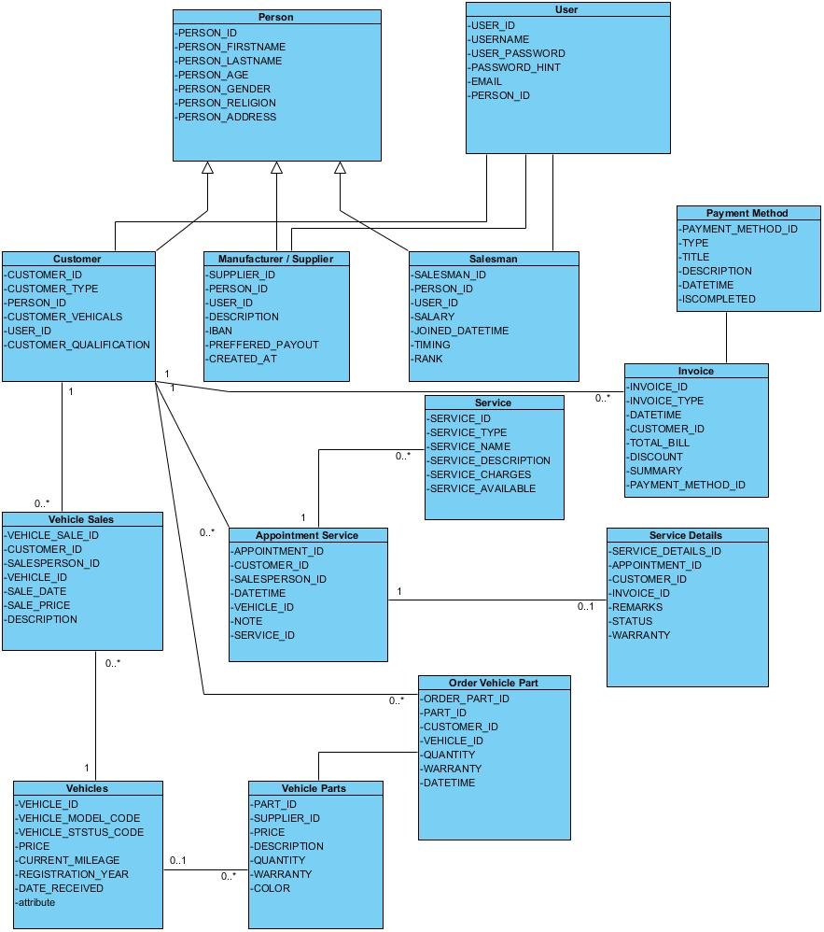

**UX Model (Ordering Vehicle Part)**

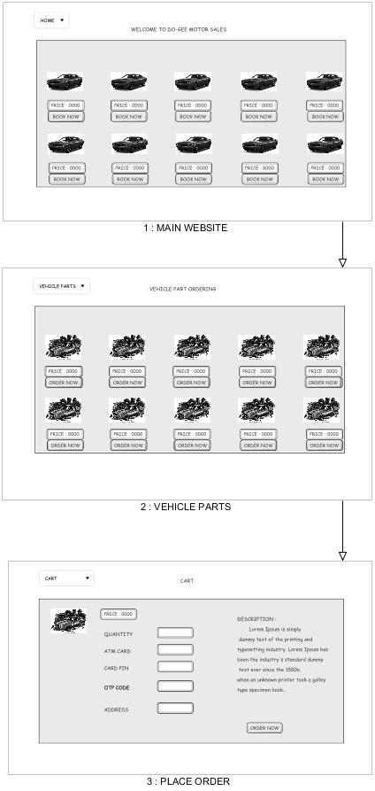

**Separately Wire Frames Pictures**

